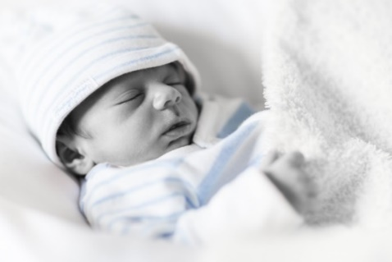Thank you for supporting the work we are doing at the Pregnancy Helpline and Resource Center of Janesville, Inc.  We invite and encourage anyone interested to visit our facility and see the work that is being done!

**Current Wish List**

Diapers & Pull-Ups Similac Advance Formula

Baby Wipes Boppy/Nursing Pillows

Infant Bath Soap, Lotion, Sunscreen Crib/sheets

Pack-n-Play/Sheets Potty Seats

Baby Bottle Brushes  Training Underwear

Puffs, Squeeze Baby food Baby & Toddler Socks

New or Gently Used Newborn - 2T Boy or Girl Clothing

**Other Ways to Give**

1) Via our web page: [www.pregnancy-helpline.org](http://www.pregnancy-helpline.org)

* Click “Support Us”, Click “Donate”, Choose to either donate with PayPal or donate with Debit or Credit Card
* You can also click to “Make this a monthly

Donation”

2) Mail a check to:

Pregnancy Helpline and Resource Center

P.O. Box 383

Janesville, WI 53547

3) Amazon Wish List <https://a.co/9OpDaLt>